**Phase 4: Process Automation (Admin)**

**1.Validation Rules :**

A Validation Rule in Salesforce is used to maintain data quality by preventing users from saving incorrect or incomplete data.

* It is written as a formula expression.
* If the formula evaluates to TRUE, Salesforce shows an error message and stops saving the record.
* Helps enforce business rules, such as valid dates, mandatory fields, or logical checks.

Validation rules in MediConnect,

1. **Appointment Date Cannot Be Past**

* **Object:** Appointment
* **Rule Name:** Appointment_Date_Check
* **Formula:** *CreatedDate < NOW()*

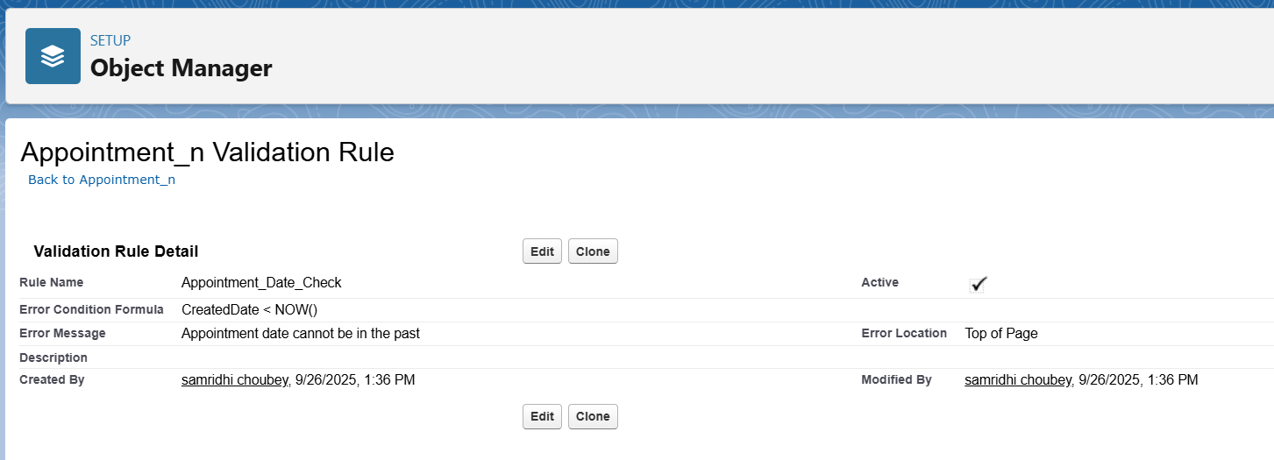

1. **Billing Amount Must Be Positive**

* Object: Billing_n
* Rule Name: Billing_Amount_Check
* Formula: Amount__c <= 0
* Amount__c <= 0
* Error Message: "Billing amount must be greater than 0."
* Use Case: Prevents wrong billing entries.

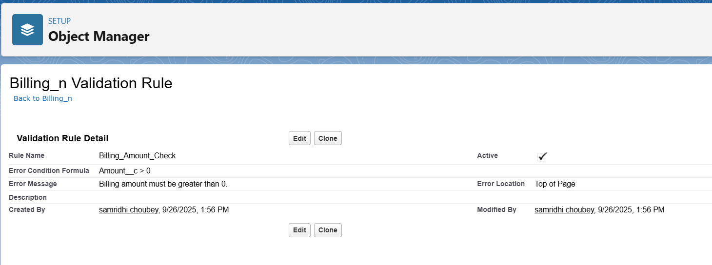

1. **Patient Age Check**

* **Object:** Patient
* **Rule Name:** Patient_Age_Check
* **Formula:** Age__c <= 0
* **Error Message:** "Patient age must be greater than 0."
* **Use Case:** Ensures no patient is saved with invalid age.

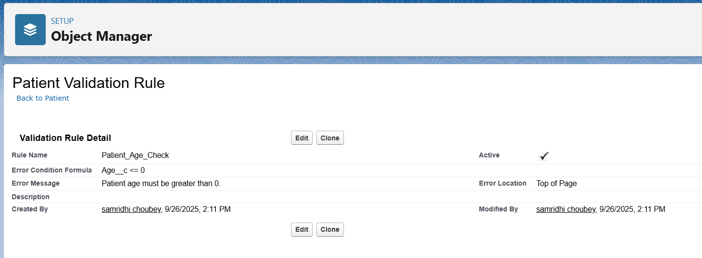

**2. Workflow Rules:**

Workflow Rules in Salesforce are automations that perform an action (like sending an email, updating a field, or creating a task) when a record meets specific conditions.  
They are if/then statements:

* If condition is true → Then action happens automatically.

Workflow rule in MediConnect,  
**1. Workflow Rule**: Appointment Confirmation Email

**Objective:** When an Appointment is scheduled, send an email confirmation to the Patient with appointment date and time.

**Steps:**

1. **Created a new Email field** (Patient_Email__c) on the **Appointment** object.
2. **Built a Record-Triggered Flow** to automatically copy the Patient’s Email (from the related Patient record) into this new field whenever an Appointment is created or updated.
3. **Created a Workflow Rule** on Appointment:
   * **Rule Criteria:** Appointment Status = "Scheduled".
   * **Action:** Email Alert.
4. **Configured the Email Alert:**
   * Recipient: **Email Field → Patient_Email__c**.
   * Email Template: Appointment Confirmation Email (includes appointment date & time).

**Result:** Whenever a new Appointment is scheduled, the Patient automatically receives a confirmation email with details.

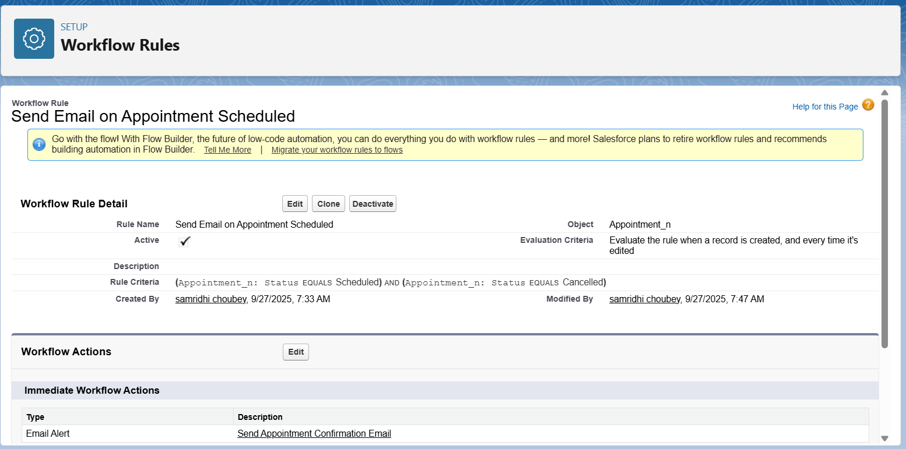

**3.Process Builder**

* A Salesforce automation tool (point-and-click) to automate if-then business processes.
* More advanced than Workflow Rules (can update multiple related records, call flows, create records, etc.).
* Example: *“When a new Appointment is created → send confirmation email to patient and also update Appointment Status to ‘Scheduled’ automatically.”*

***Firstly we have to create email temaplates and email alerts***

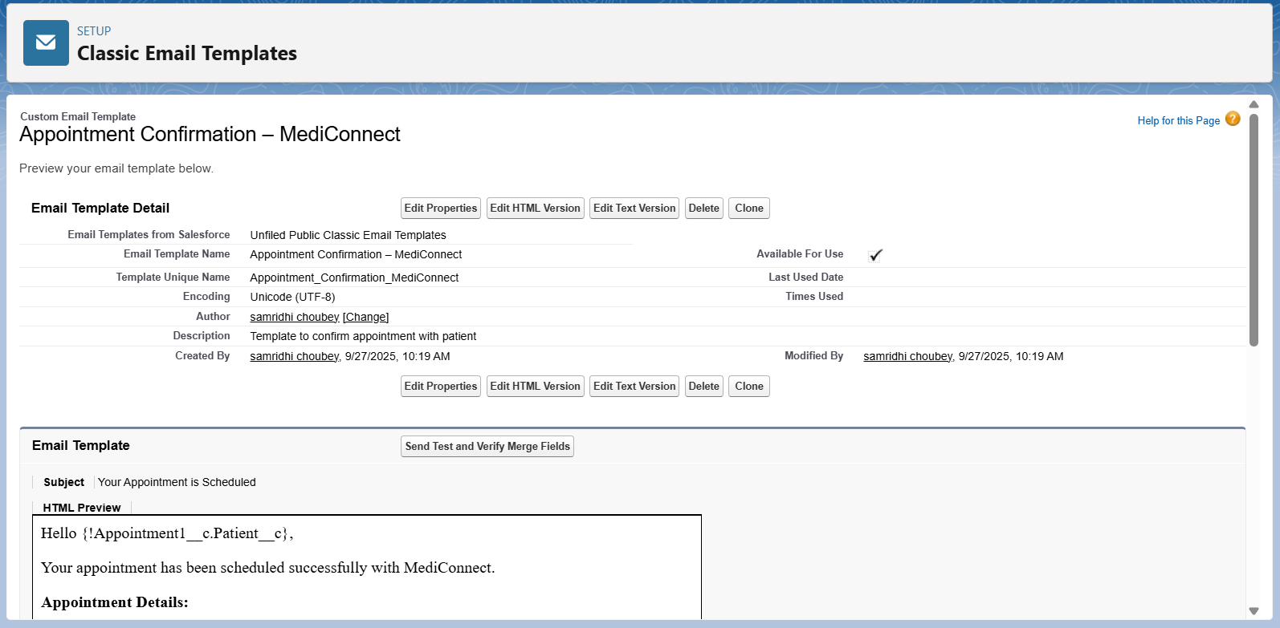

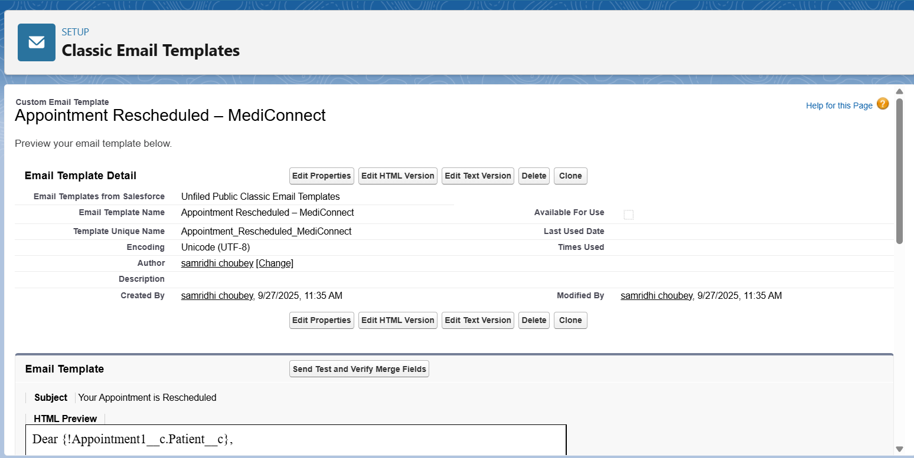

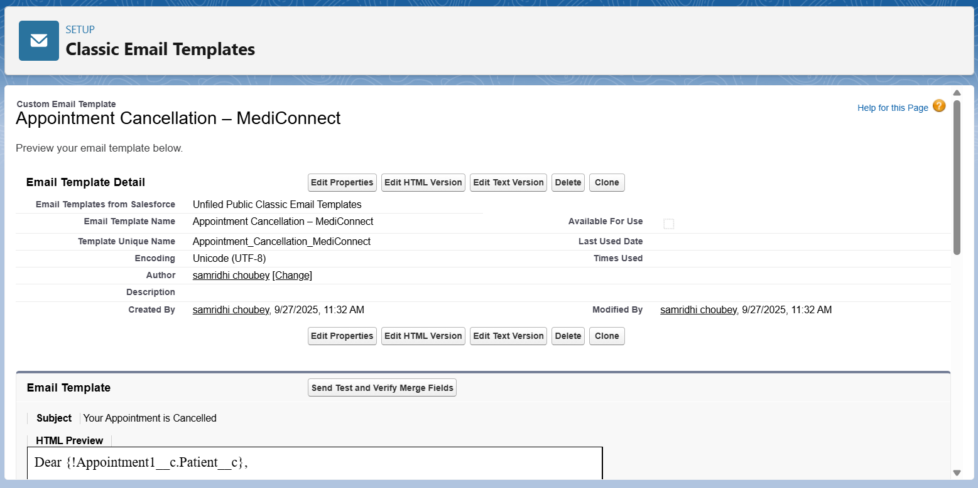

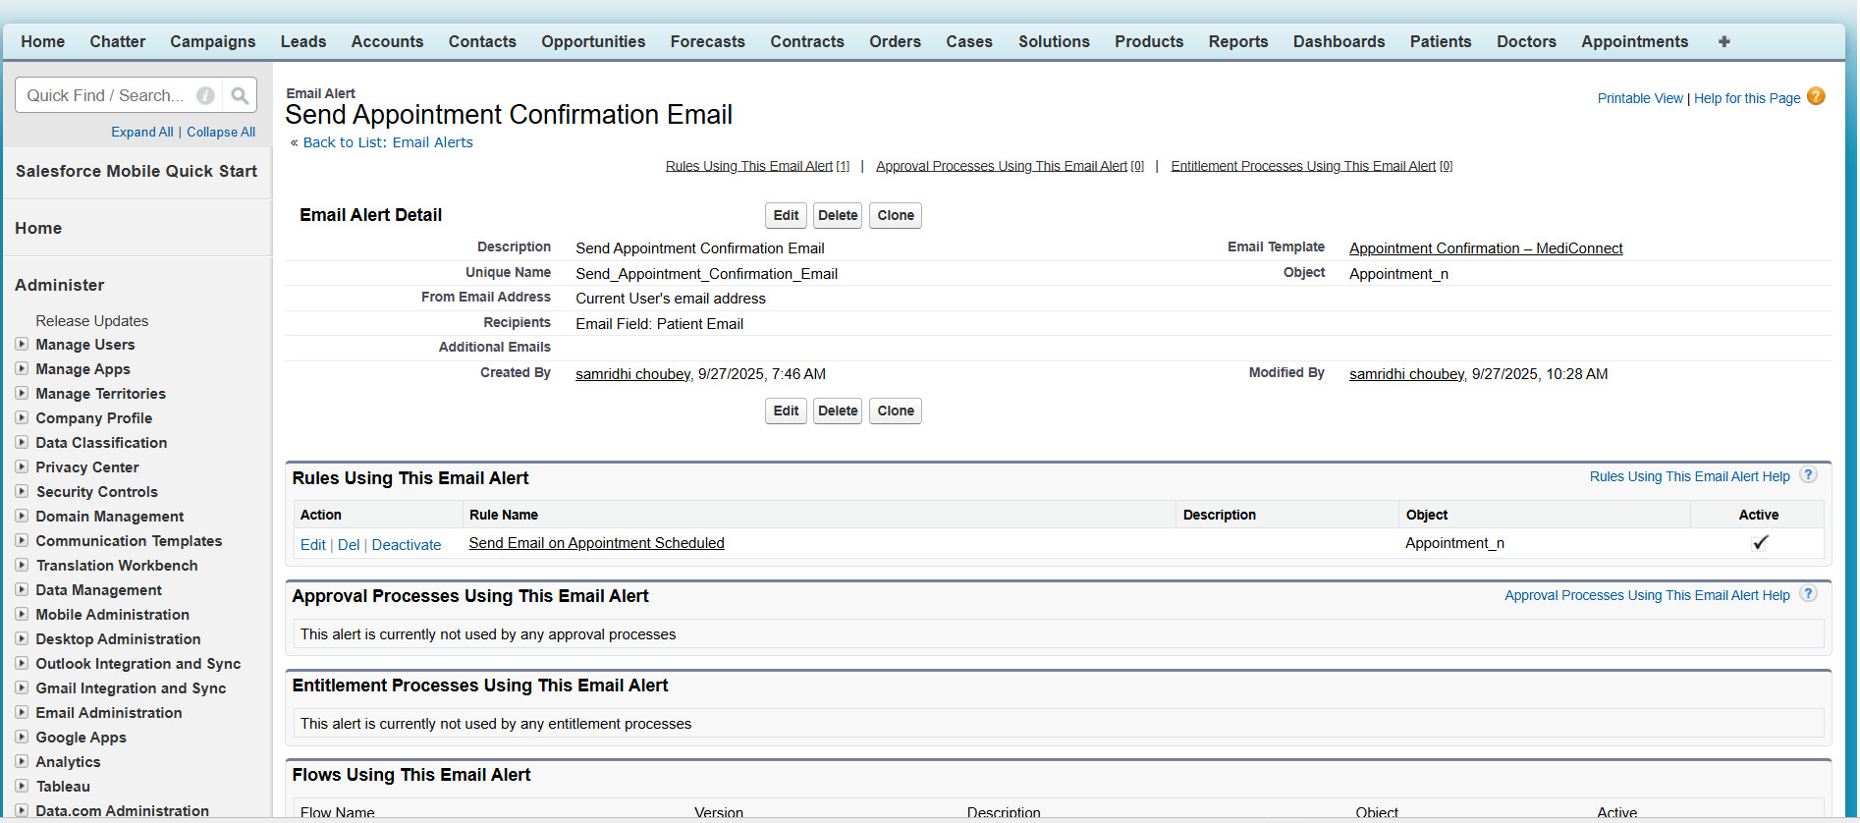

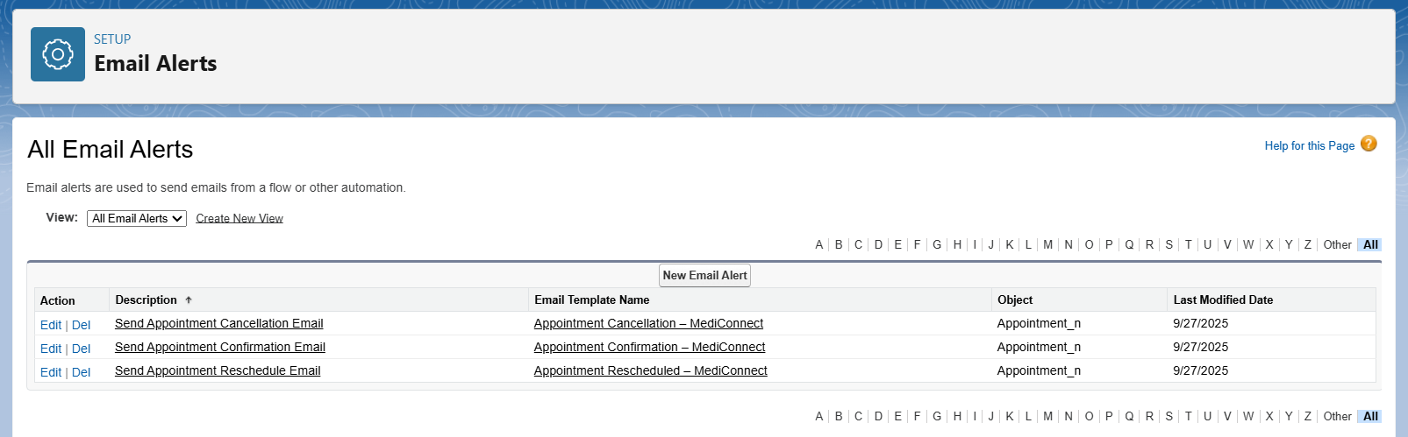

***Now we can buils the process builder- Appointment Confirmation***

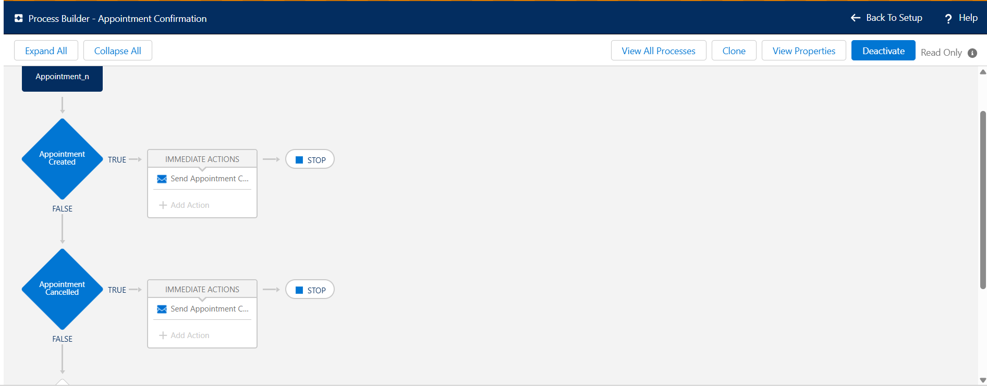

**4.Approval Process**

An Approval Process in Salesforce automates how records get approved in your org. It defines steps, approvers, and actions when a record requires approval.

Example in MediConnect:

* When a Billing record is created for insurance billing, it must be approved by the Hospital Manager before it’s finalized.

Use Cases:

* Insurance billing approval
* Special discounts approval
* Rescheduling appointments requiring manager’s consent

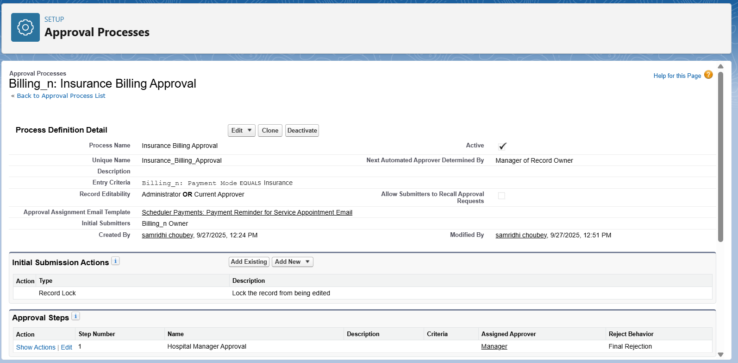

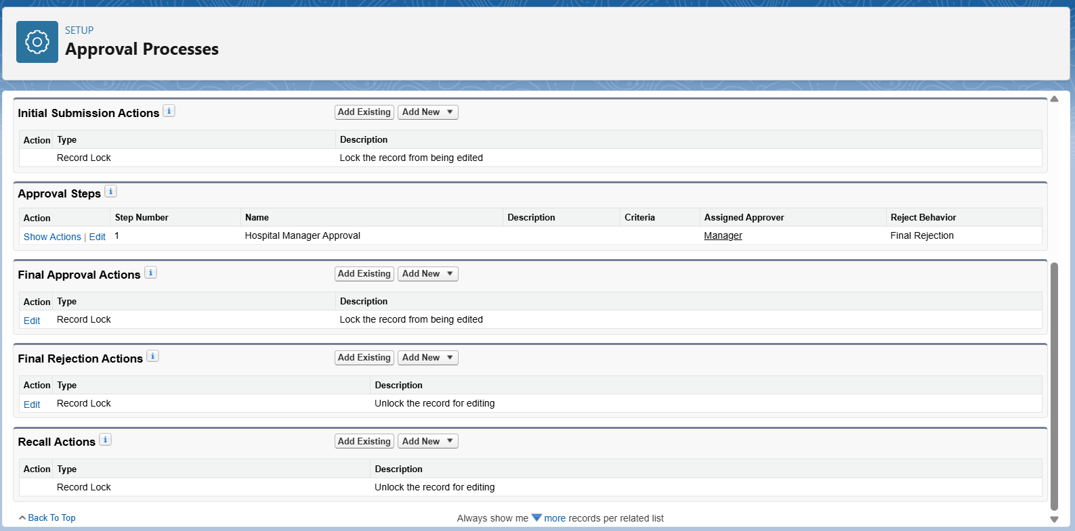

**Key Components:**

* Entry Criteria: Which records need approval?
* Approver: Who approves the record (User, Role, or Queue)
* Approval Steps: Sequence of approvals (single-step or multi-step)
* Actions: What happens on approval, rejection, or submission (Email Alert, Field Update, Task)

**5.Flow Builder (Screen, Record-Triggered, Scheduled, Auto-launched)**

A Flow automates business logic by collecting data, making decisions, and performing actions (create/update records, send emails, etc.).

1️⃣ Screen Flow

👉 A flow that takes user input (like a form) and performs actions.

Example (MediConnect): A Patient Registration Form where reception staff enters patient details.

Steps to Create:

1. Go to Setup → Flows → New Flow → Screen Flow.
2. Drag Screen Element → Add fields: Patient Name, Age, Contact, Gender.
3. Add Create Records Element → Save data into Patient__c object.
4. Connect Screen → Create Record → End.
5. Save & Activate the flow.
6. Place it on a Lightning Page for Receptionist.

2️⃣ Record-Triggered Flow

👉 Runs automatically when a record is created/updated.

Example (MediConnect): When an Appointment is scheduled, send confirmation email.

Steps:

1. Setup → Flows → New Flow → Record-Triggered Flow.
2. Select Object: Appointment__c.
3. Trigger: When a record is created or updated.
4. Condition: Status = Scheduled.
5. Add Action → Email Alert (confirmation mail to Patient).
6. Save & Activate.

3️⃣ Scheduled Flow

👉 Runs at a specific time or frequency (daily, weekly, monthly).

Example (MediConnect): Send daily reminders for next-day appointments.

Steps:

1. Setup → Flows → New Flow → Scheduled-Triggered Flow.
2. Set Schedule: Run Every Day at 8 AM.
3. Select Object: Appointment__c.
4. Condition: Appointment_Date = Tomorrow.
5. Action: Send Email Alert → Patient (reminder mail).
6. Save & Activate.

4️⃣ Auto-Launched Flow

👉 Runs in background (no UI, no trigger), usually called by Process Builder, Apex, or another Flow.

Example (MediConnect):  
When a patient is discharged, auto-launch a flow to:

* Update Patient record (Status = Inactive)
* Create Billing record
* Send Thank You Email

Steps:

1. Setup → Flows → New Flow → Auto-Launched Flow.
2. Drag Update Records Element → Update Patient Status = Inactive.
3. Drag Create Record Element → Create Billing record.
4. Add Action → Send Email Alert.
5. Save & Activate.
6. Call this flow from Process Builder when Patient Status = Discharged.

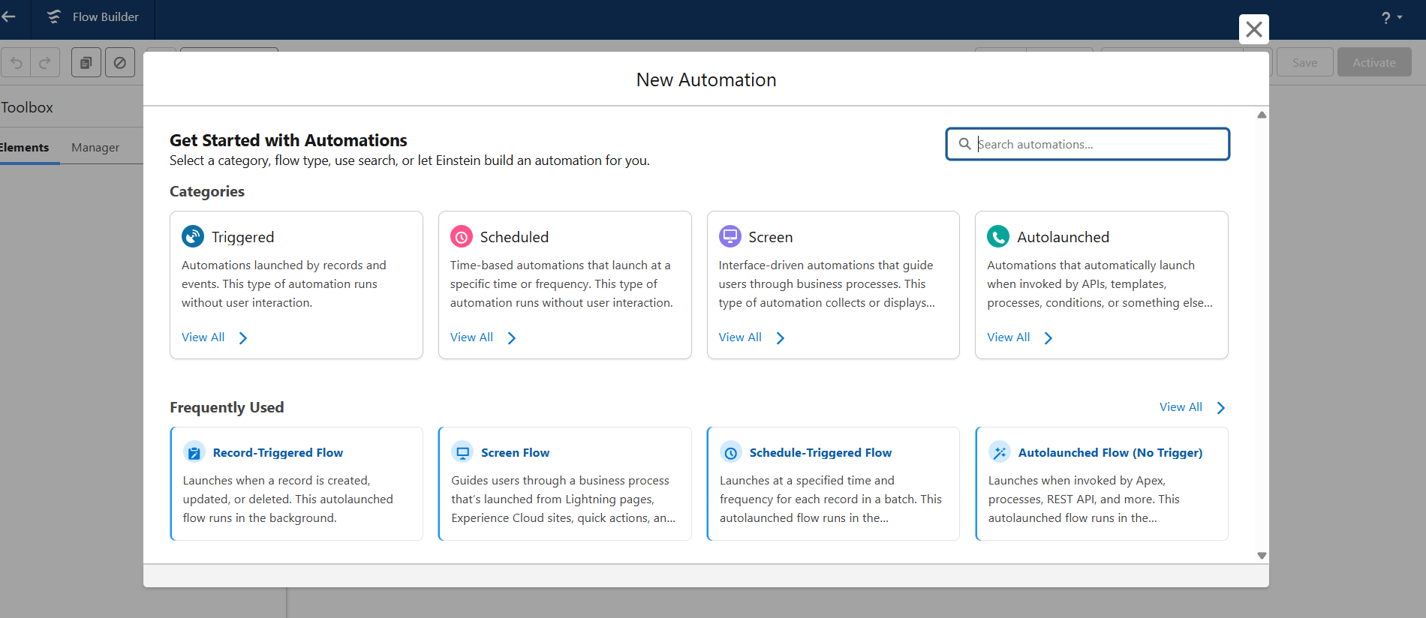

**6.Email Alerts**

Email Alerts are automated emails that Salesforce sends to users or external contacts when certain conditions are met. They are always tied to a workflow rule, process builder, approval process, or flow. Each email alert uses a pre-defined email template and is associated with recipients (like Users, Roles, or related records).

**1. Appointment Confirmation Email Alert**

* **Object:** Appointment__c
* **Email Template:** *Appointment Confirmation Template*
* **Recipients:** Patient (from Appointment__c → Patient__c lookup), Assigned Doctor (User)
* **Trigger:** When appointment status = *Scheduled* (via Process Builder / Workflow)
* **Purpose:** Ensures patient and doctor get notified with appointment details

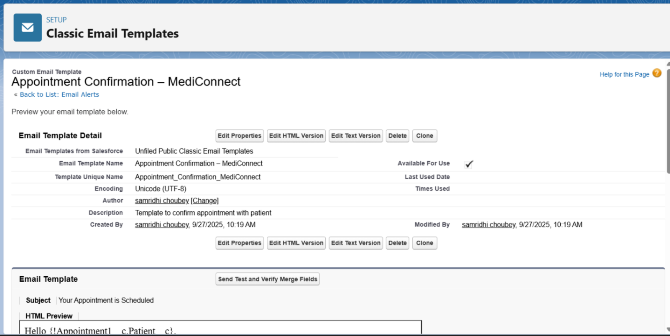

**2. Appointment Cancellation Email Alert**

* **Object:** Appointment__c
* **Email Template:** *Appointment Cancellation Template*
* **Recipients:** Patient (from Appointment__c → Patient__c lookup)
* **Trigger:** When appointment status = *Cancelled* (via Process Builder / Workflow)
* **Purpose:** Notifies patient about appointment cancellation and encourages rebooking.

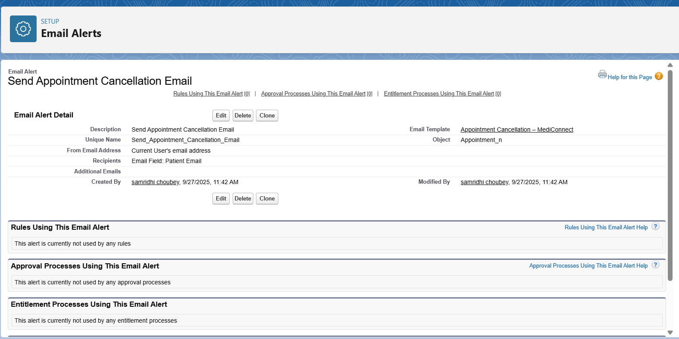

**3. Appointment Rescheduled Email Alert**

* **Object:** Appointment__c
* **Email Template:** *Appointment Reschedule Template*
* **Recipients:** Patient (from Appointment__c → Patient__c lookup), Assigned Doctor (User)
* **Trigger:** When appointment status = *Rescheduled* (via Process Builder / Workflow)
* **Purpose:** Informs patient and doctor about new appointment date and time.

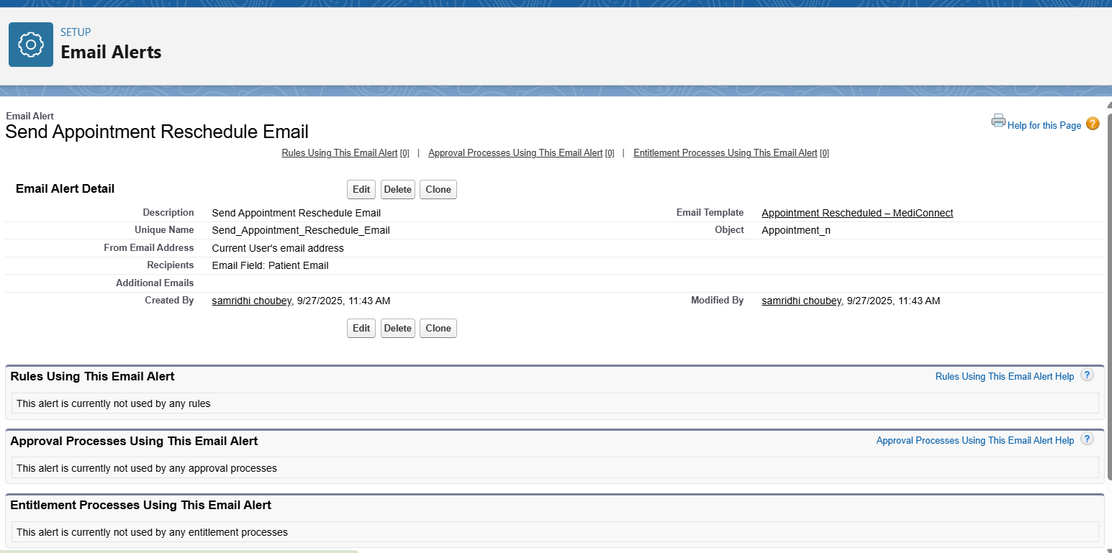

**7.Field Updates**

Field Updates in Salesforce

A Field Update is an automated action that allows Salesforce to change the value of a field on a record when certain criteria are met. It is commonly used with Workflow Rules, Process Builder, and Approval Processes.

🔹 Key Points:

* You can update standard fields or custom fields.
* Field updates can set a specific value, clear a field, or use a formula.
* Helps in reducing manual updates and ensures data consistency.

**Examples for MediConnect CRM**

1. **Appointment Status Update**
   * When a doctor marks an appointment as “Completed,” the Status field of the Appointment record automatically updates to Completed.

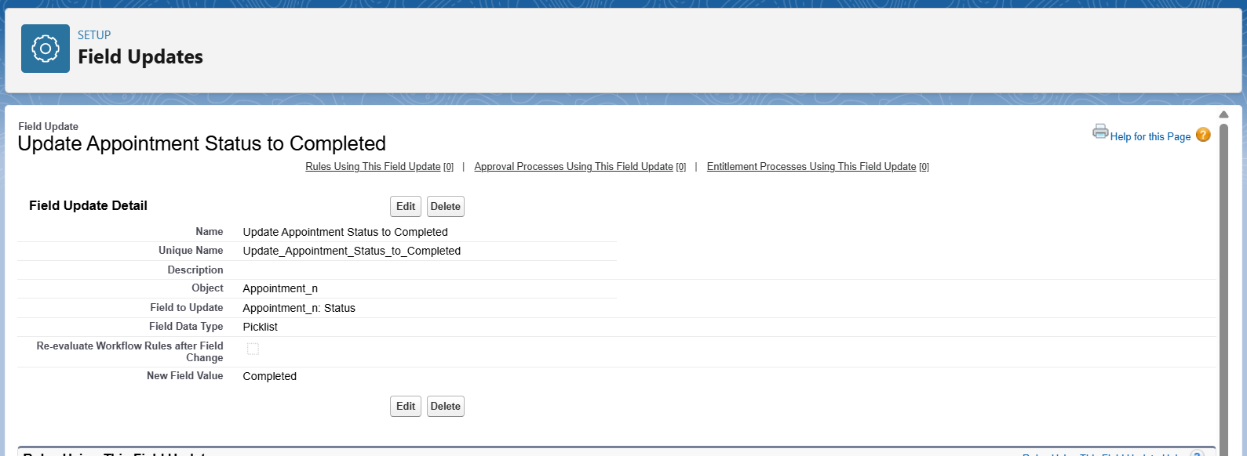

**8.Custom Notifications**

A **Custom Notification** in Salesforce allows you to send real-time alerts to users directly in Salesforce (via the **Bell icon** in the utility bar) or in the Salesforce Mobile App.

* Unlike emails, notifications are **instant and less intrusive**.
* They keep hospital staff **aware of critical updates** without leaving Salesforce.

**Examples for MediConnect CRM**

1. **New Appointment Notification**
   * When a patient books a new appointment, send a notification to the assigned doctor.
2. **Billing Notification**
   * When a bill is generated, send a notification to the Billing Officer.
3. **Emergency Appointment Notification**
   * If an appointment is marked as *Emergency*, notify the Hospital Manager immediately.

**Result**

Whenever the automation criteria are met (e.g., Appointment Created), the concerned users immediately see a **pop-up notification** in Salesforce (bell icon 🔔) or mobile app.

